Exome Variant Analysis of Chromosome 17 (GRCh38): Calling, Annotation and Benchmarking Against the GIAB Truth Set

ABSTRACT
Exome sequencing targets the protein-coding regions of the genome, where most known disease-associated variants occur, but the reliability of variant calls depends on the pipeline used and should be measured. This project built and evaluated an end-to-end germline variant-calling workflow on chromosome 17 (GRCh38) of the public Genome in a Bottle (GIAB) sample HG003. Reads were quality-controlled and trimmed, aligned with BWA-MEM, processed with GATK (duplicate marking and base quality recalibration), called with HaplotypeCaller, hard-filtered, annotated with gnomAD allele frequencies and predicted functional consequences (bcftools csq), and benchmarked against the GIAB truth set. Mean depth over the capture targets was 117x, with 99.7% of target bases covered at 20x or more. Hard filtering retained 4,381 PASS variants. Against the truth set, PASS single-nucleotide variants (SNVs) reached a precision of 0.989 and a recall of 0.976, while the indel estimates (precision 0.833, recall 1.000) rested on only 35 true-positive calls. Selecting rare or novel protein-changing variants gave 51 candidates, several of which showed signs of mapping artifacts, such as clustering or unusually high depth. The workflow therefore performed accurately for SNVs on this sample, whereas indels in repeat regions and the candidate variants require further validation.
Keywords: exome sequencing, variant calling, GATK, GIAB, benchmarking, chromosome 17

1. INTRODUCTION
1.1 Genetic Variation and Human Disease
The human genome differs between individuals at millions of positions. These differences, known as genetic variants, contribute to normal traits and to susceptibility to inherited and acquired diseases. Variants that change the amino acid sequence of a protein or disrupt splicing are particularly likely to affect function, and a large share of the variants with known disease associations lie in protein-coding regions [1]. Identifying variants accurately is therefore a basic step in genetics, from rare-disease diagnosis to cancer research.
1.2 Next-Generation Sequencing
Next-generation sequencing (NGS) technologies read millions of short DNA fragments in parallel, which makes it possible to sequence whole genomes or targeted regions at a fraction of the earlier cost and time [2]. NGS produces raw reads that must be aligned to a reference genome and analysed computationally before variants can be reported. The reliability of the final variant list therefore depends on every step of the analysis, not only on the sequencing itself.
1.3 Whole-Exome Sequencing
The exome is the set of all exons, the regions of genes that are retained in mature mRNA and encode proteins. It makes up only about 1 to 2% of the human genome [1,3]. Whole-exome sequencing (WES) uses capture probes to enrich these regions before sequencing, which allows deep coverage of coding sequence at lower cost than whole-genome sequencing [3]. Because capture is targeted, depth varies between regions, so coverage across the target regions is an important quality measure for WES data.
1.4 Types of Genetic Variants
The most common variants are single-nucleotide variants (SNVs), in which one base is replaced by another, and small insertions and deletions (indels), in which bases are added or removed. SNVs are divided into transitions (purine-to-purine or pyrimidine-to-pyrimidine changes) and transversions, and the transition/transversion (Ti/Tv) ratio is widely used as a quality indicator, because true variants show more transitions than random errors would [4]. A variant is also described by its genotype: heterozygous (0/1) when one copy of the gene carries the change, and homozygous alternate (1/1) when both copies do. Indels, particularly in repeats and homopolymers, are harder to align and call than SNVs [4].

1.5 Variant Calling Workflow
Best-practice workflows follow a standard series of steps [5–8]. Reads are first checked for quality and trimmed to remove adapters and low-quality bases with tools such as FastQC and fastp [5]. They are then aligned to the reference genome with BWA-MEM [6], and the alignments are sorted and indexed with SAMtools [7]. Duplicate reads arising from PCR are marked, and base quality scores are recalibrated using known variant sites (base quality score recalibration, BQSR) to correct systematic errors [8,9]. Coverage over the target regions is measured with tools such as mosdepth [10]. Variants are then called with the GATK HaplotypeCaller, which reassembles reads in regions that show variation, and the raw calls are filtered with hard thresholds on quality annotations to remove likely false positives [8,9].
1.6 Variant Annotation
Raw variants have little meaning until they are interpreted. Population databases such as the Genome Aggregation Database (gnomAD) report how often a variant is seen in large reference cohorts, which helps separate common variants from rare or novel ones [11]. Functional annotation predicts the effect of each variant on genes and transcripts, for example whether it changes an amino acid (missense), creates a premature stop codon (stop-gained), or alters a splice site. Tools such as bcftools csq make this prediction from gene models and take neighbouring variants on the same haplotype into account [12].
1.7 Benchmarking and the Genome in a Bottle Truth Set
A variant caller can be called accurate only if its output has been compared with a known answer. The Genome in a Bottle (GIAB) Consortium provides high-confidence variant calls and confident regions for reference samples, including HG003 [13,14]. Comparing a callset with such a truth set gives true positives (calls that match), false positives (calls that are not in the truth set) and false negatives (truth variants that were missed). From these, precision (the proportion of calls that are correct) and recall (the proportion of true variants that were found) are calculated [15]. Because the truth is reliable only inside the confident regions, comparisons are restricted to them [15].
1.8 Rationale of the Study
Each stage of an exome pipeline involves choices of tools and thresholds, and each can affect the final result, so the accuracy of a workflow should be measured and not assumed. Public reference samples with truth sets make this possible. Therefore, the present study implemented a standard germline variant-calling workflow on an exome from the GIAB sample HG003, restricted to chromosome 17 (GRCh38). Chromosome 17 was chosen because it is large and gene-rich, while keeping run times manageable in a free cloud notebook environment. The workflow was used to call, filter and annotate variants, to evaluate their accuracy against the GIAB truth set, and to select and critically assess rare or novel protein-changing candidates.

2. AIM
To build and evaluate an end-to-end germline variant-calling workflow on exome sequencing data from the Genome in a Bottle (GIAB) sample HG003, restricted to chromosome 17 (GRCh38), and to annotate the variants and critically assess rare or novel protein-changing candidates.
3. OBJECTIVES
→ To retrieve the HG003 exome reads, capture targets and reference resources for chromosome 17 and prepare them for analysis.
→ To assess read quality, trim adapters and low-quality bases, and align the reads to the GRCh38 chromosome 17 reference.
→ To mark duplicate reads, recalibrate base quality scores and measure sequencing coverage over the capture targets.
→ To call variants with GATK HaplotypeCaller and filter them using hard thresholds for single-nucleotide variants (SNVs) and indels.
→ To annotate the variants with gnomAD allele frequencies and predicted functional consequences using bcftools csq.
→ To benchmark the filtered variants against the GIAB truth set and calculate precision and recall.
→ To select rare or novel protein-changing candidates and assess their reliability using genotype, depth, population frequency and clustering.
→ To record software versions and save the results so that the analysis is reproducible.

4. METHODOLOGY
4.1 Overall Workflow
The analysis was performed in a Google Colab notebook using command-line bioinformatics tools installed with conda. The workflow followed the standard steps of a germline variant-calling pipeline:

∞ Data and Resource Retrieval
∞ Read Quality Control and Trimming
∞ Alignment to the Reference Genome
∞ Duplicate Marking and Base Quality Score Recalibration
∞ Coverage Analysis
∞ Variant Calling and Filtering
∞ Variant Annotation (Population Frequency and Functional Consequence)
∞ Benchmarking against the GIAB Truth Set
∞ Candidate Variant Selection and Evaluation
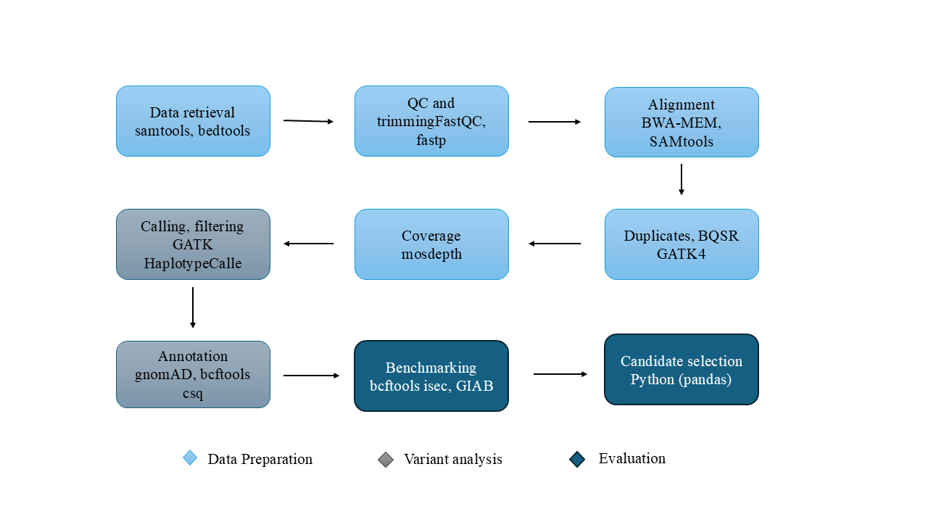
Figure 1. Overview of the exome variant analysis workflow.

4.2 Data and Resources
The exome reads came from the public Genome in a Bottle (GIAB) sample HG003, sequenced on an Illumina NovaSeq platform with IDT exome capture (approximately 100x). The data were obtained from the DeepVariant exome case study test data. Reads mapping to chromosome 17 were extracted from the alignment file and converted back to FASTQ format, giving 2,387,574 read pairs (151 bp). The source file was an already-aligned BAM, and 17,568 singleton reads were dropped when converting to FASTQ. The analysis used the GRCh38 (hg38) reference genome for chromosome 17 with UCSC-style chromosome naming (“chr17”). The capture target regions were restricted to chromosome 17 and merged, giving 11,933 regions covering 2.16 Mb. The resources used for each step are listed in Table 1.
Table 1. Data and resources used in the study.
Resource | Description | Source
Sequencing reads | HG003 exome, NovaSeq, IDT capture (~100x); chr17 subset, 2,387,574 read pairs | DeepVariant exome case study
Reference genome | GRCh38 (hg38), chromosome 17 | UCSC
Capture targets | IDT/Novogene GRCh38 capture regions; chr17, merged (11,933 regions) | DeepVariant exome case study
Known variant sites | Mills and 1000 Genomes gold-standard indels; 1000 Genomes phase 1 high-confidence SNPs | Broad Institute hg38 resource bundle
Population frequencies | gnomAD allele frequencies (af-only, hg38) [11] | GATK best-practices resources
Truth set | GIAB HG003 GRCh38 benchmark v4.2.1 and confident-region BED [13,14] | GIAB Consortium
Gene annotation | Ensembl GRCh38 release 113 gene models (GFF3), chr17 converted to “chr17” naming [16] | Ensembl

4.3 Software and Versions
All analysis tools were installed from the conda-forge and Bioconda channels. The tools, versions and purposes are given in Table 2. The exact versions used were also recorded in a text file saved with the results.
Table 2. Software used in the analysis.
Tool | Version | Purpose
FastQC | v0.13.0 | Read quality assessment
fastp | 1.4.0 | Adapter and quality trimming
MultiQC | 1.35 | Combined QC report
BWA-MEM | 0.7.19-r1273 | Read alignment
SAMtools | samtools 1.25 | Sorting, indexing, alignment statistics
GATK | The Genome Analysis Toolkit (GATK) v4.6.2.0 | Duplicate marking, base quality recalibration, variant calling and filtering
mosdepth | mosdepth 0.3.3 | Coverage over target regions
bcftools | bcftools 1.25 | Normalisation, annotation, benchmarking comparisons
bcftools csq | part of bcftools 1.25 | Functional consequence prediction
bedtools | v2.31.1 | Interval operations on target and truth-set regions
Python (pandas, NumPy, matplotlib) | 3.13.18 (2.2.3, 2.5.4, 3.10.0) | Tables and plots
Google Colab |  | Cloud notebook environment

4.4 Read Quality Control and Trimming
Read quality was assessed before and after trimming with FastQC, and the reports were combined with MultiQC [17]. Adapters were detected automatically for paired-end reads and removed with fastp [5]. Reads shorter than 36 bp after trimming were discarded. Trimming statistics (reads before and after, Q30 rate and mean read length) were taken from the fastp report.

4.5 Alignment
Trimmed read pairs were aligned to the GRCh38 chromosome 17 reference with BWA-MEM [6], with a read group assigned (sample HG003, platform Illumina). The alignments were sorted and indexed with SAMtools [7], and alignment statistics (mapped reads and properly paired reads) were obtained with SAMtools flagstat.
4.6 Duplicate Marking and Base Quality Score Recalibration
PCR duplicates were marked with GATK MarkDuplicates [8,9], and the duplication rate was taken from its metrics file. Base quality scores were then recalibrated with GATK BaseRecalibrator and ApplyBQSR [8,9], using the Mills and 1000 Genomes gold-standard indels and the 1000 Genomes high-confidence SNPs as known sites. Recalibration was restricted to the capture targets plus 100 bp of padding on each side.
4.7 Coverage Analysis
Sequencing depth over the capture targets was calculated from the recalibrated alignment with mosdepth [10]. The mean depth per target region and the fraction of target bases covered at 10x, 20x and 30x were recorded, and regions with a mean depth below 20x were counted.
4.8 Variant Calling
Variants were called with GATK HaplotypeCaller [8,9] on the recalibrated alignment, restricted to the capture targets plus 100 bp of padding. The output was a compressed VCF file of raw variants, which was separated into SNVs and indels with GATK SelectVariants. Records that belong to neither group (mixed multiallelic sites containing both an SNV and an indel allele) were identified with bcftools isec [7] and counted.
4.9 Variant Filtering
SNVs and indels were filtered separately with GATK VariantFiltration, using hard thresholds on variant quality annotations (Table 3). The filtered files were merged with bcftools concat, and only variants that passed all filters (PASS) were kept. The number of variants removed by each filter was recorded.
Table 3. Hard-filter thresholds used for variant filtering.
Annotation | SNV filter | Indel filter
QD (quality by depth) | <2.0 | <2.0
FS (Fisher strand) | >60.0 | >200.0
SOR (strand odds ratio) | >3.0 | >10.0
MQ (mapping quality) | <40.0 | not used
MQRankSum | < -12.5 | not used
ReadPosRankSum | < -8.0 | < -20.0

4.10 Variant Annotation
Normalisation and population frequency. PASS variants were normalised with bcftools norm [7], which splits multiallelic sites and left-aligns variants against the reference. Allele frequencies from gnomAD [11] were added to each variant with bcftools annotate.
Functional consequences. The Ensembl GRCh38 gene annotation (GFF3) [16] was restricted to chromosome 17 and its chromosome names were converted to the “chr17” style used by the reference. Consequences were predicted with bcftools csq [12], with variants treated as phased and up to 50 consequences allowed per variant. Because csq reports one effect for every overlapping transcript, the most severe consequence for each variant was selected using the order of severity shown in Table 4, ignoring effects on nonsense-mediated decay (NMD) transcripts.
4.11 Benchmarking against the GIAB Truth Set
The evaluation regions were defined as the intersection of the capture targets and the GIAB high-confidence regions, using bedtools [18]. The GIAB truth set (v4.2.1) [13,14] was normalised in the same way as the callsets. Both the raw and the PASS callsets were then compared with the truth set inside the evaluation regions with bcftools isec [7]. Variants found in both sets were counted as true positives (TP), variants found only in the callset as false positives (FP), and variants found only in the truth set as false negatives (FN). Precision (TP / (TP + FP)) and recall (TP / (TP + FN)) were calculated separately for SNVs and indels [15].

4.12 Candidate Variant Selection
Candidate variants were selected and assessed in Python (pandas) using the criteria in Table 4. Variants were first filtered by depth and genotype quality. Population rarity was then classified from the gnomAD allele frequency, and variants that were rare or absent from gnomAD and had a protein-changing consequence were kept as candidates. Each candidate was also flagged if it lay within 200 bp of another rare or novel variant (clustered) or had a depth above 300x, roughly 2.5 times the mean target depth (high depth), because these patterns can indicate mapping or repeat artifacts. The candidates were then reviewed by position, genotype, depth, frequency and local context.
Table 4. Criteria used to select and flag candidate variants.
Criterion | Definition
Depth and genotype quality | DP ≥ 10 and GQ ≥ 20
Rare | gnomAD allele frequency < 1%
Novel | Not found in gnomAD
Protein-changing consequence | Stop-gained, splice acceptor, splice donor, frameshift, start-lost, stop-lost, inframe insertion, inframe deletion, missense
Order of severity (most to least) | Splice acceptor, splice donor, stop-gained, frameshift, stop-lost, start-lost, inframe insertion, inframe deletion, missense, splice region, stop-retained, synonymous, 5' UTR, 3' UTR, intron, non-coding
Clustered flag | Within 200 bp of another rare or novel variant
High-depth flag | DP > 300

5. RESULTS
5.1 Read Quality and Trimming
The chromosome 17 subset of the HG003 exome contained 2,387,574 read pairs of 151 bp. After adapter removal and quality trimming with fastp, 99.1% of reads were retained (2,367,112 read pairs), and the proportion of bases with a quality score of at least 30 (Q30) rose from 94.0% to 94.4%. Adapters were trimmed from 162,530 reads. The key quality values are summarised in Table 5, and the combined FastQC and MultiQC report is provided with the results.
5.2 Alignment and Duplicate Marking
Of the trimmed reads, 99.98% aligned to the chromosome 17 reference and 99.5% were properly paired. The duplication rate estimated by GATK MarkDuplicates was 15.7%.
Table 5. Read quality, alignment and duplication summary.
Metric | Value
Read pairs in raw data | 2,387,574
Reads retained after trimming | 99.1% (2,367,112 read pairs)
Q30 rate, before and after trimming | 94.0% and 94.4%
Reads with adapters trimmed | 162,530
Reads mapped | 99.98%
Reads properly paired | 99.5%
Duplication rate | 15.7%

5.3 Coverage over the Capture Targets
Mean sequencing depth over the 11,933 target regions (2.16 Mb) was 117x. The fractions of target bases covered at 10x, 20x and 30x or more were 99.9%, 99.7% and 98.7%, respectively, and 48 of the 11,933 regions had a mean depth below 20x (Table 6, Figure 2).
Table 6. Coverage summary over the capture targets.
Metric | Value
Target regions | 11,933 (2.16 Mb)
Mean depth | 117x
Bases covered at ≥10x | 99.9%
Bases covered at ≥20x | 99.7%
Bases covered at ≥30x | 98.7%
Regions with mean depth below 20x | 48

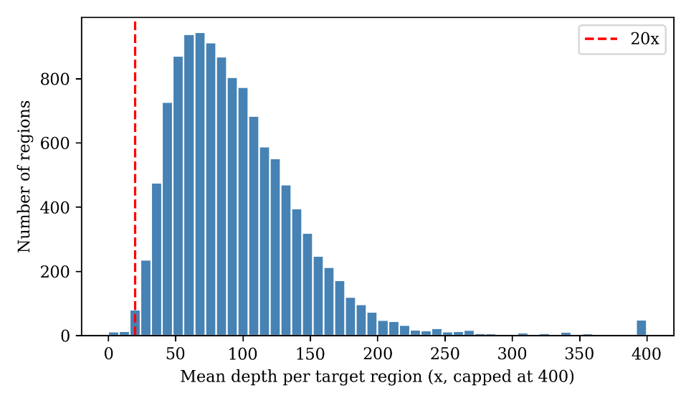
Figure 2. Distribution of mean sequencing depth across the 11,933 capture target regions. The dashed line marks 20x.
5.4 Variant Calling and Filtering
GATK HaplotypeCaller produced 4,711 raw variant records, consisting of 4,060 SNVs, 647 indels and 4 mixed multiallelic sites (SNV plus indel alleles, genotype 1/2) that were assigned to neither group by SelectVariants. Hard filtering removed 270 SNVs and 56 indels, leaving 4,381 PASS variants (3,790 SNVs and 591 indels). The transition/transversion ratio of the PASS SNVs was 2.66 (Table 7). Hard filtering removed 270 SNVs and 56 indels (Figure 3a). Heterozygous PASS calls were centred on an alternate-allele fraction of 0.5, as expected for well-called variants (Figure 3b).
Table 7. Variant counts before and after hard filtering.
Variant type | Raw | PASS
SNVs | 4,060 | 3,790
Indels | 647 | 591
Mixed multiallelic sites | 4 | Not filtered
Total | 4,711 | 4,381

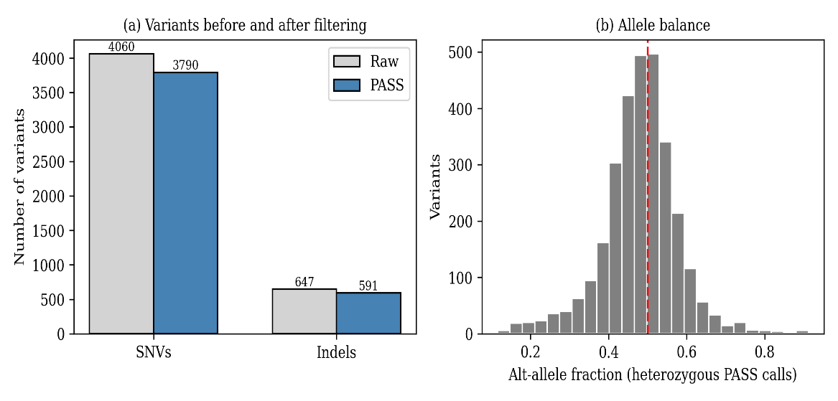
Figure 3. (a) Number of SNVs and indels before and after hard filtering. (b) Alternate-allele fraction of heterozygous PASS calls; the dashed line marks the expected value of 0.5.
5.5 Accuracy against the GIAB Truth Set
Accuracy was measured against the GIAB HG003 truth set (v4.2.1) inside the regions that were both captured and GIAB-confident. For PASS SNVs, precision was 0.989 and recall 0.976. For PASS indels, precision was 0.833 and recall 1.000, based on 35 true-positive indels. Filtering reduced the number of false-positive SNVs from 42 to 16 and the number of false-positive indels from 13 to 7, while the recall of SNVs fell from 0.990 to 0.976 (Table 8). The precision and recall values are shown in Figure 4.
Table 8. Accuracy of the raw and PASS callsets against the GIAB truth set.
Callset | Type | TP | FP | FN | Precision | Recall
Raw | SNV | 1460 | 42 | 15 | 0.972 | 0.990
Raw | Indel | 35 | 13 | 0 | 0.729 | 1.000
PASS | SNV | 1439 | 16 | 36 | 0.989 | 0.976
PASS | Indel | 35 | 7 | 0 | 0.833 | 1.000
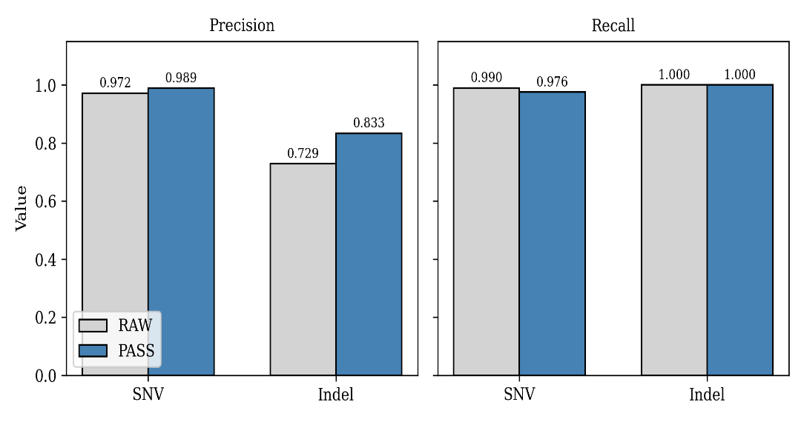
Figure 4. Precision and recall of the raw and PASS callsets against the GIAB truth set for SNVs and indels.

5.6 Variant Annotation
Population frequency. After normalisation, the PASS callset contained 4,434 records, because multiallelic sites were split. Of these, 3,994 (90%) were present in gnomAD. Among the 4,381 records of 4,434 with depth of at least 10 and genotype quality of at least 20, 3,843 were common (gnomAD allele frequency of 1% or more), 123 were rare and 415 were absent from gnomAD (Figure 5a).
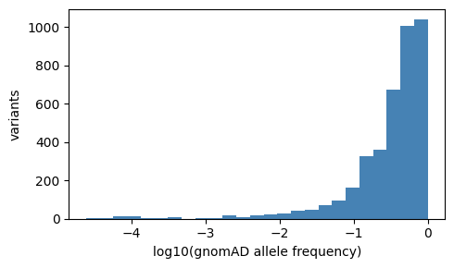
Figure 3. Distribution of gnomAD allele frequencies for the annotated variants.
Functional consequences. The most severe consequence per variant was intronic for 2,351 records, synonymous for 656 and missense for 609 (Table 9). High-impact classes were uncommon: 6 stop-gained, 9 splice donor or acceptor, 4 start-lost and 1 frameshift variant (Figure 5b).
Table 9. Most severe predicted consequence per variant.
Consequence | Number of variants
Intron | 2,351
Synonymous | 656
Missense | 609
Stop-gained | 6
Splice donor or acceptor | 9
Start-lost | 4
Frameshift | 1
Only on NMD transcripts | 67
No overlapping | 40
Other (UTR, splice region, non-coding, in-frame and others) | 691
Total | 4,434

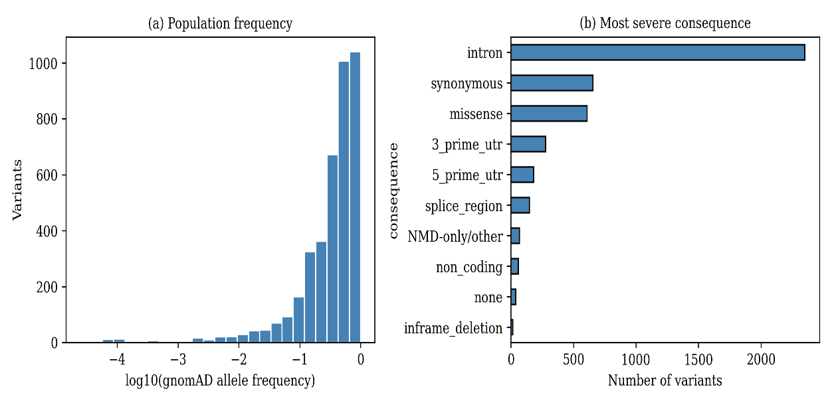
Figure 5. (a) Distribution of gnomAD allele frequencies. (b) Number of variants in each predicted functional consequence class.
5.7 Candidate Variants
Selecting variants that were rare or absent from gnomAD and had a protein-changing consequence gave 51 candidates: 41 missense, 6 in-frame insertions, 3 in-frame deletions and 1 frameshift. These 51 records represent 50 distinct sites, because one site carries two insertion alleles. Nine candidates were flagged as clustered (within 200 bp of another rare or novel variant) and 4 as high depth (above 300x).
Table 10 summarises the evidence for selected candidates. Figure 6 shows that the flagged candidates lie above 300x or in clusters, whereas FASN, USP43, AOC3 and SGSH have depths of about 200x to 240x and no flags. By contrast, the two homozygous CCDC40 missense variants lay 49 bp apart and had depths of 343x and 328x, and the KRTAP4-5 insertion had a depth of 496x.

Table 10. Evidence summary for selected candidate variants (positions on GRCh38 chromosome 17).
Gene | Position | Consequence | Genotype | Depth | gnomAD_AF | Flags
FASN | 82,088,256 | missense | 0/1 | 204 | 0.000098 | none
USP43 | 9,728,628 | missense | 0/1 | 240 | 0.000074 | none
AOC3 | 42,852,329 | missense | 0/1 | 207 | 0.0067 | none
SGSH | 80,210,880 | missense | 0/1 | 200 |  | none
  not in gnomAD
CCDC40 | 80,090,216 and 80,090,265 | missense | 1/1 | 343 and 328 |  | clustered, high depth
  not in gnomAD
KRTAP4-5 | 41,149,523 | inframe insertion | 1/1 | 496 |  | high depth
  not in gnomAD
 | 7,513,774 | frameshift | 1/1 | 152 |  | none
  POLR2A
  not in gnomAD

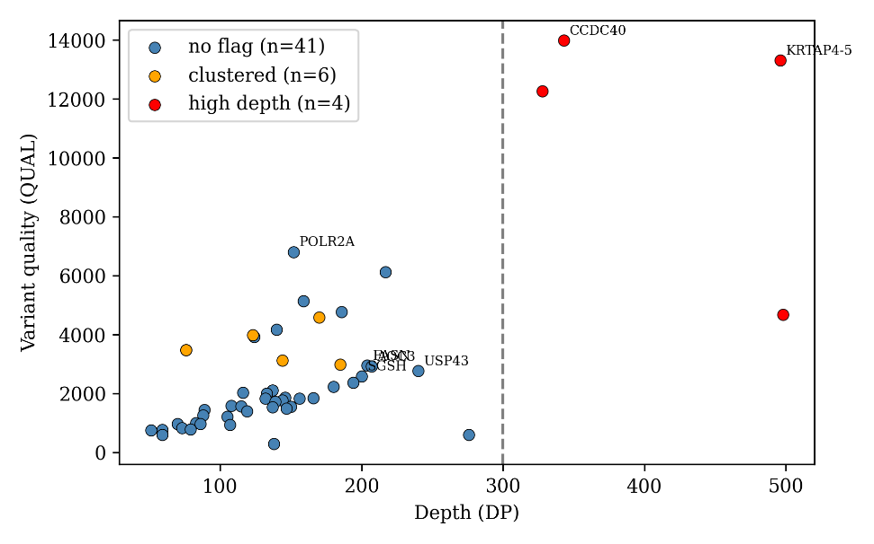
Figure 6. Depth and variant quality of the 51 candidate variants, coloured by artifact flag. The dashed line marks 300x.

5.8 Final Candidate Prioritization
The candidates were compared on genotype, depth, allele balance, gnomAD frequency, flags and local context, and ranked by variant quality (QUAL). FASN (chr17:82,088,256), USP43 (chr17:9,728,628), AOC3 (chr17:42,852,329) and SGSH (chr17:80,210,880) were the highest-ranking candidates that were heterozygous, not clustered, not unusually deep and had balanced allele fractions (about half of the reads supporting the alternate allele); they are a shortlist, and other unflagged heterozygous candidates of lower quality score (for example CLUH and GPR179) remain in Table A2. Higher-ranking candidates were set aside because CCDC57, LIAT1, AATK and KDM6B were clustered, the in-frame insertion in BCL6B and the deletion in LIAT1 were heterozygous calls with about 90% of reads supporting the alternate allele, which suggests misalignment in repeat sequence, and the novel homozygous variants in FDXR, MTNAP1 and ENPP7 are unusual for a real variant and were treated as suspicious like the CCDC40 and POLR2A variants.

6. DISCUSSION
6.1 Data Quality and Coverage
The input data were of high quality. Trimming retained 99.1% of reads, the Q30 rate was 94.4% after trimming, and 99.98% of reads aligned to the reference. The duplication rate of 15.7% is within the range commonly seen in capture-based sequencing, where PCR amplification during library preparation produces duplicate reads [8,9]. Mean depth over the capture targets was 117x, and 99.7% of target bases were covered at 20x or more, which is generally sufficient for confident genotyping of heterozygous variants. The 48 target regions below 20x should be regarded as less reliable, because variants in them may have been missed.
6.2 Variant Calling and Filtering
HaplotypeCaller produced 4,711 raw records, and hard filtering retained 4,381 PASS variants. The Ti/Tv ratio of 2.66 is close to the values usually reported for exome data (about 2.8 to 3.0) [4]. The slightly lower value is expected because the targets were padded by 100 bp, which adds intronic and flanking sites where the ratio is lower. The value therefore supports the overall quality of the SNV calls. The benchmark (Table 8) showed that filtering traded recall for precision. For SNVs, it removed 26 false positives (42 to 16) but also 21 true variants (15 to 36 missed), so the combined measure of precision and recall (F1, calculated from Table 8) changed little, from about 0.981 to 0.982. For indels, filtering improved precision from 0.729 to 0.833 without losing any true variants. The hard thresholds were therefore useful mainly for indels. A trained model such as VQSR might perform better, but one sample is too few for it [8].
6.3 Accuracy against the Truth Set
The SNV calls were highly accurate (precision 0.989, recall 0.976), which is the expected performance for a well-covered exome. The indel results (precision 0.833, recall 1.000) are encouraging but should be interpreted with caution, because they rest on only 35 true-positive indels, so a single call changes the estimates considerably. Indels are known to be harder to align and call than SNVs [4,15]. The benchmark is also restricted to regions that were both captured and GIAB-confident, so it does not measure performance in repetitive or otherwise difficult regions [13–15]. The values therefore describe how well the pipeline performs in the easier part of the exome and are likely to be an upper bound for the whole chromosome.

6.4 Annotation and Candidate Variants
Ninety per cent of the annotated records were present in gnomAD [11], so most variants were previously observed in large reference cohorts, as expected for a healthy reference individual. Most variants were intronic or synonymous, which is expected because the targets were padded by 100 bp, and only 51 were rare or novel and protein-changing. Examination of these candidates showed how unreliable a simple “rare and protein-changing” filter can be. The most dramatic candidates, such as the homozygous CCDC40 and KRTAP4-5 variants, were novel, clustered or unusually deep, which is typical of mapping artifacts in repeated or duplicated regions, and the homozygous frameshift in the essential gene POLR2A is more likely to be an artifact than a real loss of function. The more plausible candidates (FASN, USP43, AOC3 and SGSH) were heterozygous, at normal depth and unflagged. Because HG003 is a healthy reference individual, rare protein-changing variants are expected and do not indicate disease, and none of the candidates was validated.
Functional consequences were predicted with bcftools csq [12] because the SnpEff database could not be downloaded in the cloud environment. Both tools predict effects on transcripts, but SnpEff also gives impact categories (HIGH, MODERATE, LOW), which were not available here. Since csq reports an effect for every overlapping transcript, selecting the most severe effect per variant, and ignoring NMD transcripts, was necessary to obtain meaningful counts.
6.5 Reproducibility
All steps were run in one notebook, tool versions were recorded, and the results tables were saved, so the analysis can be repeated.

7. CONCLUSION
An end-to-end germline variant-calling workflow was built and evaluated on chromosome 17 of the GIAB sample HG003 (GRCh38). The data were of high quality, with 99.98% of reads aligned and a mean depth of 117x over the capture targets (99.7% of bases at 20x or more). Variant calling and hard filtering gave 4,381 PASS variants (3,790 SNVs and 591 indels). Against the GIAB truth set, PASS SNVs reached a precision of 0.989 and a recall of 0.976, and indels a precision of 0.833 and a recall of 1.000, although the indel estimate rests on only 35 true-positive calls.
Annotation with gnomAD frequencies and bcftools csq consequences produced 51 rare or novel protein-changing candidates. Review of genotype, depth and clustering showed that several of them, including the CCDC40, KRTAP4-5 and POLR2A variants, were likely to be artifacts, whereas FASN, USP43, AOC3 and SGSH were the most plausible. None of the candidates was validated.
Overall, the workflow is accurate for SNVs in well-covered regions, and benchmarking and critical review of the candidates were essential to judge how far the results could be trusted. Future work could extend the analysis to the whole exome and further GIAB samples, compare hard filters with VQSR or a deep-learning caller, add SnpEff or VEP annotation and ClinVar information, and inspect candidates visually in IGV.

8. LIMITATIONS OF THE STUDY
- The analysis used a single public reference sample and one chromosome (chromosome 17), so the results may not apply to other samples or to the whole exome.
- Hard filters were used instead of a trained recalibration model (VQSR), and some false positives and false negatives remain.
- Four mixed multiallelic sites (SNV plus indel alleles) were not carried through the filtering step.
- Indels in repeat regions are less reliable, and the indel accuracy estimate is based on only 35 true-positive calls.
- “Not in gnomAD” may be overstated for indels, because the same indel can be written in different ways and fail to match the database record.
- The accuracy values apply only to captured, GIAB-confident regions and do not reflect performance in difficult regions.
- Benchmarking was done with bcftools isec, which matches variants by position and alleles only. It is not haplotype-aware and does not compare genotypes, so a variant written differently in the callset and the truth set can be counted as both a false positive and a false negative. Dedicated tools such as hap.py or vcfeval [15] are recommended and would give more reliable estimates.
- Functional annotation used bcftools csq, which gives consequence names but no impact categories, and does not report upstream, downstream or intergenic effects.
- The candidate variants were not validated, for example by visual inspection in IGV or by ClinVar lookup.

9. REFERENCES
9.1 Research Articles
- Bamshad MJ, Ng SB, Bigham AW, et al. Exome sequencing as a tool for Mendelian disease gene discovery. Nat Rev Genet. 2011;12(11):745–755.
- Goodwin S, McPherson JD, McCombie WR. Coming of age: ten years of next-generation sequencing technologies. Nat Rev Genet. 2016;17(6):333–351.
- Ng SB, Turner EH, Robertson PD, et al. Targeted capture and massively parallel sequencing of 12 human exomes. Nature. 2009;461(7261):272–276.
- DePristo MA, Banks E, Poplin R, et al. A framework for variation discovery and genotyping using next-generation DNA sequencing data. Nat Genet. 2011;43(5):491–498.
- Chen S, Zhou Y, Chen Y, Gu J. fastp: an ultra-fast all-in-one FASTQ preprocessor. Bioinformatics. 2018;34(17):i884–i890.
- Li H. Aligning sequence reads, clone sequences and assembly contigs with BWA-MEM. arXiv. 2013;1303.3997.
- Danecek P, Bonfield JK, Liddle J, et al. Twelve years of SAMtools and BCFtools. GigaScience. 2021;10(2):giab008.
- Van der Auwera GA, Carneiro MO, Hartl C, et al. From FastQ data to high-confidence variant calls: the Genome Analysis Toolkit best practices pipeline. Curr Protoc Bioinformatics. 2013;43:11.10.1–11.10.33.
- McKenna A, Hanna M, Banks E, et al. The Genome Analysis Toolkit: a MapReduce framework for analyzing next-generation DNA sequencing data. Genome Res. 2010;20(9):1297–1303.
- Pedersen BS, Quinlan AR. Mosdepth: quick coverage calculation for genomes and exomes. Bioinformatics. 2018;34(5):867–868.
- Karczewski KJ, Francioli LC, Tiao G, et al. The mutational constraint spectrum quantified from variation in 141,456 humans. Nature. 2020;581(7809):434–443.
- Danecek P, McCarthy SA. BCFtools/csq: haplotype-aware variant consequences. Bioinformatics. 2017;33(13):2037–2039.
- Zook JM, McDaniel J, Olson ND, et al. An open resource for accurately benchmarking small variant and reference calls. Nat Biotechnol. 2019;37(5):561–566.
- Wagner J, Olson ND, Harris L, et al. Benchmarking challenging small variants with linked and long reads. Cell Genom. 2022;2(5):100128.
- Krusche P, Trigg L, Boutros PC, et al. Best practices for benchmarking germline small-variant calls in human genomes. Nat Biotechnol. 2019;37(5):555–560.
- Harrison PW, Amode MR, Austine-Orimoloye O, et al. Ensembl 2024. Nucleic Acids Res. 2024;52(D1):D891–D899.
- Ewels P, Magnusson M, Lundin S, Käller M. MultiQC: summarize analysis results for multiple tools and samples in a single report. Bioinformatics. 2016;32(19):3047–3048.
- Quinlan AR, Hall IM. BEDTools: a flexible suite of utilities for comparing genomic features. Bioinformatics. 2010;26(6):841–842.
9.2 Database and Software Resources
- FastQC: https://www.bioinformatics.babraham.ac.uk/projects/fastqc/
- fastp: https://github.com/OpenGene/fastp
- MultiQC: https://multiqc.info/
- BWA: https://github.com/lh3/bwa
- SAMtools and BCFtools: https://www.htslib.org/
- GATK: https://gatk.broadinstitute.org/
- mosdepth: https://github.com/brentp/mosdepth
- BEDTools: https://bedtools.readthedocs.io/
- gnomAD: https://gnomad.broadinstitute.org/
- Genome in a Bottle (GIAB): https://www.nist.gov/programs-projects/genome-bottle
- Ensembl: https://www.ensembl.org/
- UCSC Genome Browser downloads: https://hgdownload.soe.ucsc.edu/
- DeepVariant exome case study data: https://github.com/google/deepvariant
- Bioconda: https://bioconda.github.io/
- Google Colab: https://colab.research.google.com/

10. APPENDICES
APPENDIX I
software_versions.txt
Table A1. Software versions used in the analysis.
APPENDIX II
variants_candidates.csv
Table A2. The 51 rare or novel protein-changing candidate variants, with consequence, genotype, depth, gnomAD frequency and flags.
APPENDIX III
benchmark_vs_giab.csv
Table A3. Precision and recall of the raw and PASS callsets against the GIAB truth set.
APPENDIX IV
qc_summary.csv
Table A4. Read and variant count summary.
APPENDIX V
variants_all.csv
Table A5. All 4,434 annotated variant records, with consequence, gene and gnomAD frequency.

APPENDIX VI
multiqc_report.html
Combined FastQC and fastp quality report for the raw and trimmed reads.

